### Redoubt Lake Sockeye Salmon

Redoubt Lake, located on the outer coast of Baranof Island, approximately 19 km south of Sitka, Alaska, supports a run of sockeye salmon that is harvested primarily in terminal subsistence and sport fisheries and, to a much lesser extent, mixed stock commercial fisheries in Sitka Sound. Sockeye salmon escapements have been enumerated at an adult counting weir at the outlet of the lake in all but one year since 1982 (the weir has been operated by the USDA Forest Service since the mid-1990s). Cooperative ADF&G and Forest Service lake fertilization enhancement projects have been conducted nearly annually at Redoubt Lake since the mid-1980s. Liquid fertilizer was applied annually during 1984–1987 and 1990–1995, followed by a less intensive program using dry fertilizer, which has been applied annually by the Forest Service since 1999 (Geiger 2003; Koller et al. 2014). In addition, a small-scale sockeye salmon egg incubation project was conducted at Redoubt Lake in 5 years during the 1980s–1990s, and 900,000 Chinook salmon fry were stocked in the lake in 1986 (Geiger 2003). The effect of the nutrient enhancement program on freshwater production and adult recruitment of sockeye salmon is difficult to assess due to the lack of data from non-fertilized years with which to compare to fertilized years (Beauchamp and Overman 2004); all but three brood years since 1982 (1987, 1995, 1996) experienced some level of lake fertilization.

In 2003, ADF&G recommended a biological escapement goal range of 10,000–25,000 Redoubt Lake sockeye salmon based on a stock-recruit analysis of brood years 1982–1996 (Geiger 2003). In that same year, however, the Board of Fisheries set an optimal escapement goal range of 7,000–25,000 sockeye salmon and adopted a management plan (5 AAC 01.760 *Redoubt Bay and Lake Sockeye Salmon Fisheries Management Plan*) that provides guidelines for allocating harvest between subsistence, sport, and commercial fisheries based on inseason projections of total escapement. Since 2003, escapements have averaged 45,300 fish (range: 10,019–101,067 fish) and reported subsistence harvests averaged 5,400 fish (range: 599–13,683 fish). As outlined in the Redoubt fisheries management plan, directed commercial purse seine fisheries can occur only when the escapement is projected to exceed 40,000 fish. Harvest rates since 2003 averaged 22% in the 8 years when directed commercial purse seine fisheries were prosecuted and averaged 15% in all other years. In 2018 and 2019, the directed commercial fishery attracted more effort than in previous years, which resulted in estimated commercial purse seine harvests of 22,900 fish (2018) and 39,300 fish (2019) and total harvest rates of 32% (2018) and 47% (2019).

**Escapement goal review:** Available run-reconstruction data included weir counts (1982–2018; with the exception of 1998, when the weir was not operated), age composition data from the escapement (with the exception of 1998), and harvest data, including estimated commercial harvest (provided by ADF&G Sitka Area Management Biologists Eric Coonradt and Aaron Dupuis), estimated sport harvest, and reported subsistence harvest. A Bayesian approach was used to describe the spawner-recruit relationship (after log-transforming both sides of the standard Ricker equation (Ricker 1954), the Ricker model was fit to the data using a linear regression equation) conducted using two sets of data:

1. Model 1, brood years 1982–2013; following Geiger (2003), the missing 1998 escapement was estimated from regression of 1982–2018 escapements on subsistence harvests (R2 = 0.90); the age composition of the 1998 run was then estimated using the average age at return, all brood years combined (Figure 9); and
2. Model 2, brood years 1999–2013; a shorter time series that did not require imputing values and encompassed all years when the lake was fertilized only with dry fertilizer.

Parameter and management reference point estimates from Model 1 and Model 2 were very similar and, despite the addition of 17 years of escapement and return data, were similar to the values estimated by Geiger (2003), though most reference point estimates (e.g., *S*MSY) were slightly larger (Table 8). Based on the 2.5th and 97.5th percentiles, which define 95% credible intervals for the parameters, the parameter estimates from Model 2 (not shown) were much more variable than Model 1. The range of escapements estimated to produce at least 90% of MSY was approximately 12,000–27,000 fish (Model 1) and 11,500–27,000 fish (Model 2), again very similar to the range of 11,000–25,000 fish reported by Geiger (2003). For simplicity, Geiger (2003) recommended the escapement goal be rounded to 10,000–25,000 fish. ~~The probability of achieving at least 90% of MSY drops considerably, to 20%, at the lower bound of 10,000 fish; however, escapements in the range of 10,000–25,000 fish provide an estimated 75–100% probability of achieving at least 80% of MSY~~ (Figure 9). At a lower bound of 10,000 fish, there is an estimated 73% probability of achieving at least 80% of MSY and an estimated 7% probability of achieving at least 90% of MSY (Figure 10). At an upper bound of 25,000 fish, there is an estimated 98% probability of achieving at least 80% of MSY and an estimated 74% probability of achieving at least 90% of MSY (Figure 10). **The escapement goal committee recommended maintaining the current biological escapement goal range of 10,000–25,000 sockeye salmon, counted annually at the Redoubt Lake weir. Given this result it is likely the *optimal* escapement goal of 7,000–25,000 fish (5 AAC 01.760) developed by the Board of Fisheries will also not change.** Future escapement goal review for this stock would benefit from use of a Bayesian age-structured state-space model to better account for missing data and associated uncertainty due to the lack of weir operations and sampling in 1998.

Table 8.–Parameter and management reference point estimates from a Bayesian spawner-recruit models fitted to Redoubt Lake sockeye salmon brood years 1982–2013 compared to estimates reported by Geiger (2003). The 2.5th and 97.5th percentiles, define 95% credible intervals for the parameters. The contrast in spawners for Model 1 is 169, the contrast in spawners for Model 2 is 34, and the contrast in spawners for Geiger (2003) is 160. The 90% lower and upper *S*MSY are point estimates and not posterior medians from the Bayesian model.

|  |  |  |  |  |  |
| --- | --- | --- | --- | --- | --- |
| **Parameter** | **Model 1a** | | | **Model 2b** | **Geiger**  **(2003)c** |
|  | 2.5thPercentile | Median | 97.5th percentile | Median |  |
| ** | 3.15 | 5.49 | 9.59 | 7.99 | 4.50 |
| ln(**) | 1.15 | 1.70 | 2.26 | 2.08 | 1.50 |
| ln(*'*)* * | 1.65 | 2.2018 | 2.90 | 2.59 | 2.15 |
| ** | 0.00002769 | 0.00004076 | 0.00005408 | 0.000044980 | 0.000043  0.000043 |
| ** | 0.78 | 0.99 | 1.31 | 1.00 | 1.14 |
| *S*EQ | 43,939 | 53,946 | 73,376 | 57,601 | 49,993 |
| *S*MAX | 18,493 | 24,536 | 36,116 | 22,232 | 23,250  23,256 |
| *S*MSY | 15,189 | 18,576 | 25,456 | 18,175 | 17,400 |
| *U*MSY | 0.64 | 0.76 | 0.87 | 0.83 | 0.75 |
| MSY | 33,628 | 60,421 | 122,352 | 89,875 | 53,266 |
| 90% *S*MSY Lower lowerLower |  | 11,813 |  | 11,507 | 11,040 |
| 90% *S*MSY Upper |  | 27,034 |  | 26,941 | 25,200 |
| aModel 1: Brood years 1982–2013; the missing 1998 escapement was estimated by regression of escapement on subsistence harvest (Geiger 2003), and age composition of the 1998 run was based on average return by age class, all brood years combined. | | | | | |
| bModel 2: Brood years 1999–2013. | | | | | |
| cEstimates for brood years 1982–1996 were derived from Geiger (2003; page 20). | | | | | |

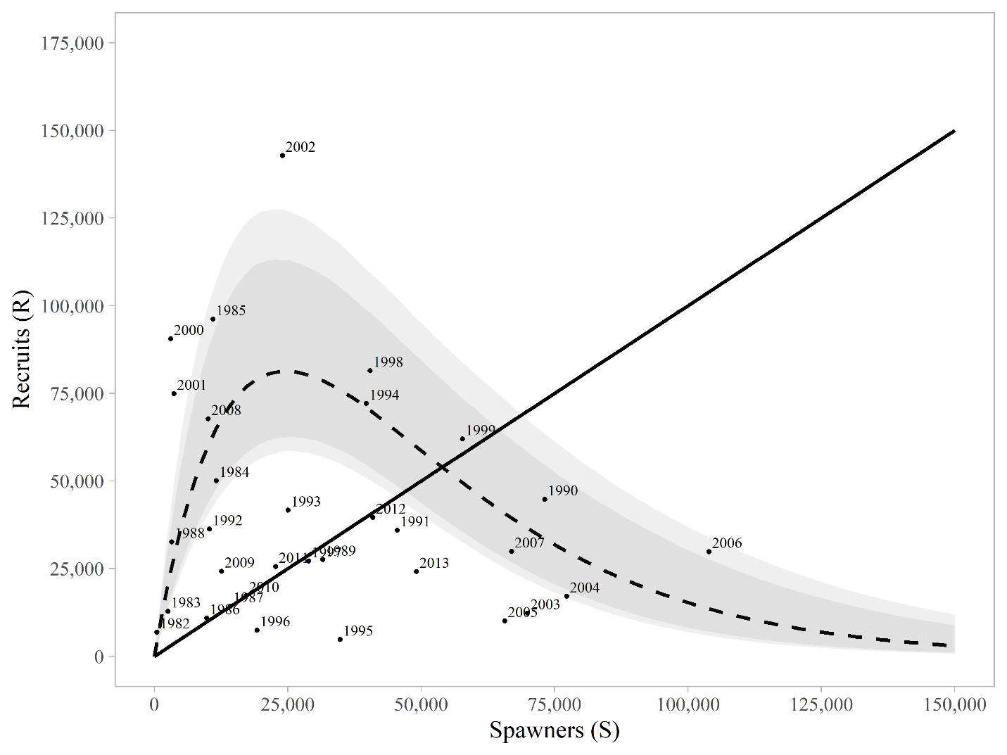

Figure 9.–Plausible spawner-recruit relationships (shaded regions around the dashed line) for Redoubt Lake sockeye salmon as derived from a Bayesian approach (brood years 1982–2013). The observed recruits and spawners are plotted as brood year labels. The heavy dashed line is the Ricker relationship constructed from ln(**’) and ** posterior medians with 90% and 95% credible intervals (shaded areas). Recruits replace spawners on the solid diagonal line.

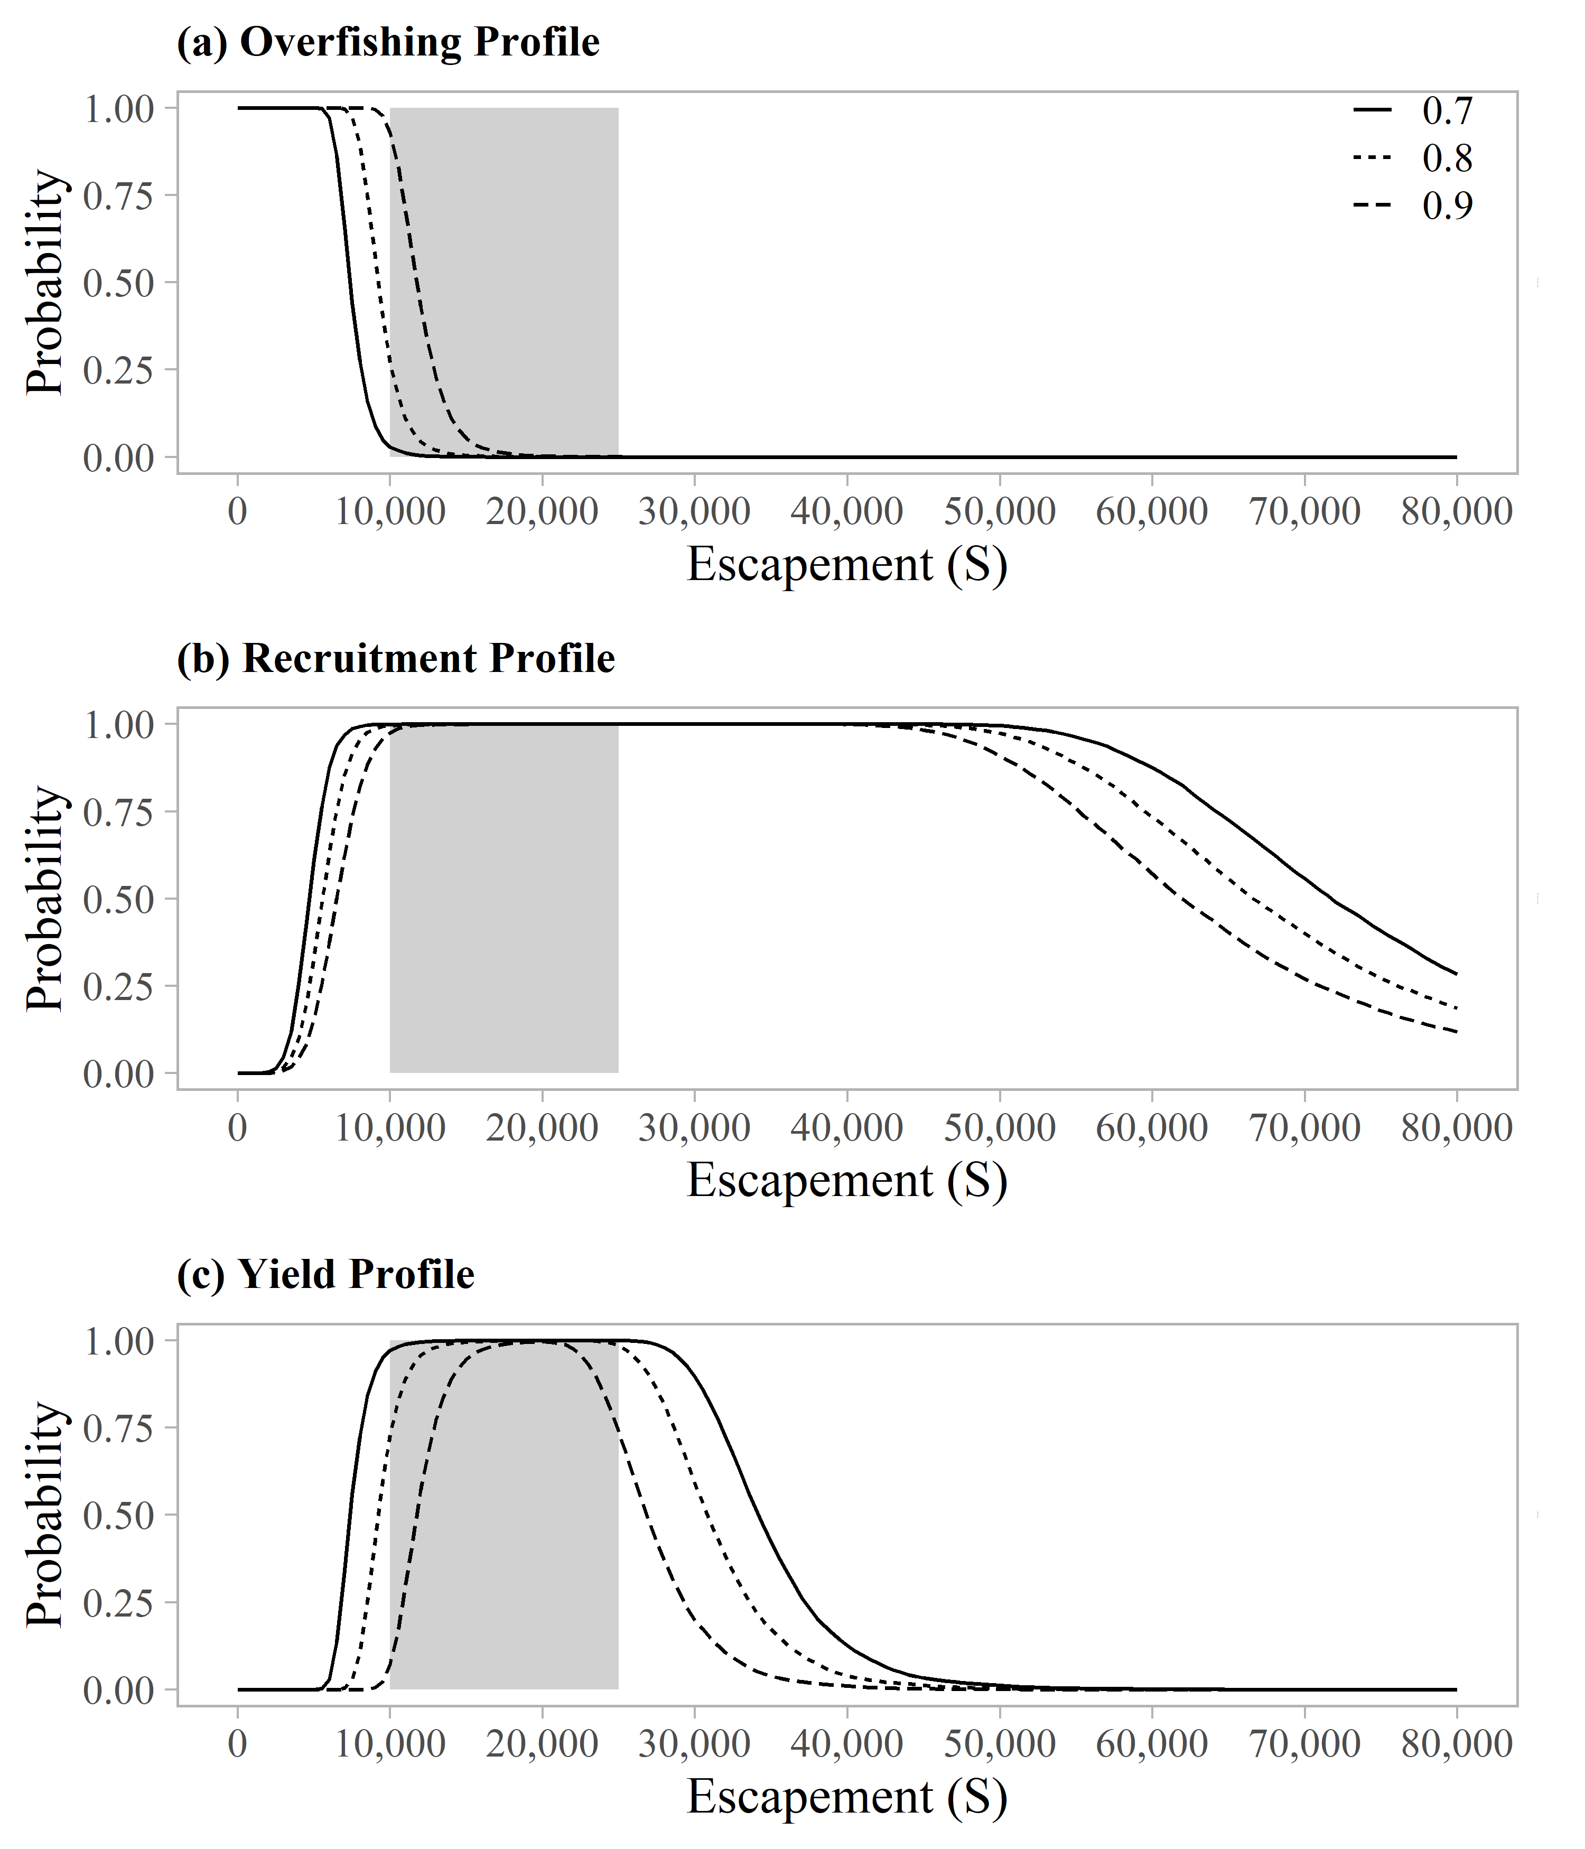

Figure 10.–Overfishing profiles (OFPs), optimal recruitment profiles (ORPs), and optimal yield profiles (OYPs) for Redoubt Lake sockeye salmon as derived from a Bayesian approach (brood years 1982–2013). OYPs and ORPs show probability that a specified spawning abundance will result in specified fractions (70%, 80%, and 90% line) of maximum sustained yield or maximum recruitment. OFPs show the probability that reducing escapement to a specified spawning abundance will result in less than specified fractions of maximum sustained yield. The shaded region shows the current biological escapement goal range of 10,000 to 25,000 spawners.